La Mirada Little League Fields 16044 Alicante Rd. La Mirada, CA 90638
Parking lot
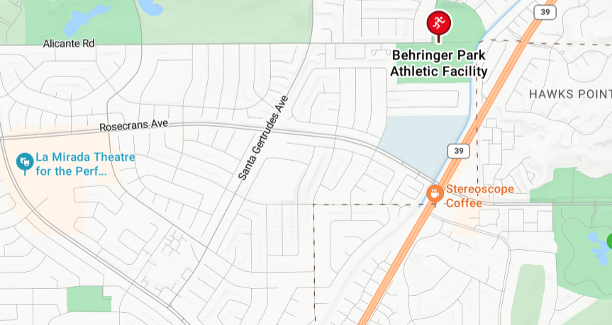
South
WEST
EAST
North

